**EXPERIMENT 4**

**RELATIONAL MODEL FOR SAILOR BOAT DATABASE**

**Aim:** Draw a relational model for sailors database.

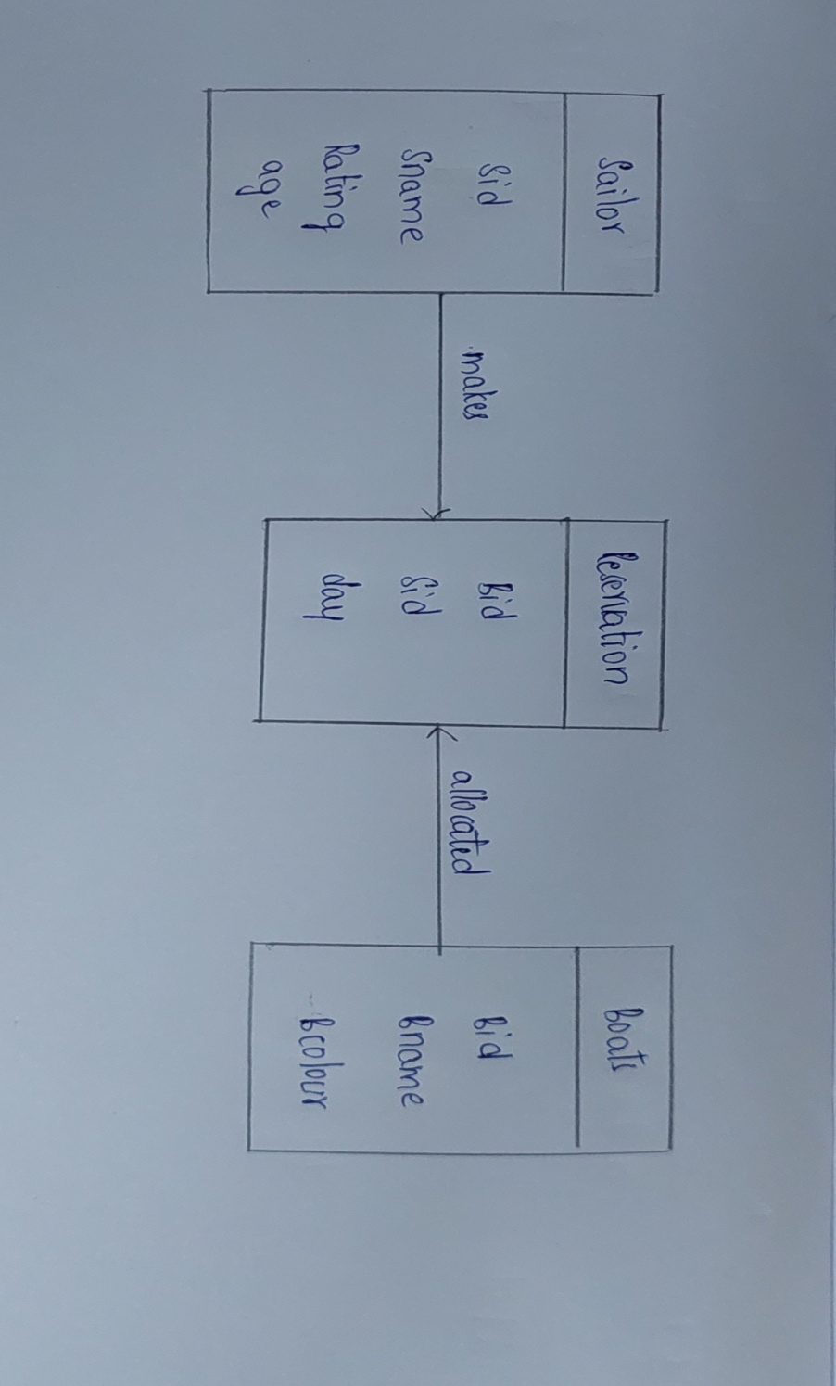

allocated

makes

Bid

Bname

Bcolour

**Boats**

Bid

Sid

day

**Reservation**

Sid   
Sname  
Rating  
age

**Sailor**